McDonald’s Sales Analysis

Executive Summary
• This study examines sales performance data from a McDonald’s outlet to uncover major trends and understand customer purchasing behavior.
• The analysis covers product category performance, best-selling menu items, sales patterns by day and time, and customer meal preferences.
• Through data visualization and interpretation, the study identifies insights that support better menu planning, targeted promotions, and improved operational efficiency.
• It also reveals seasonal and time-based buying patterns, highlights high-profit items, and determines the most effective periods for staffing and marketing efforts.

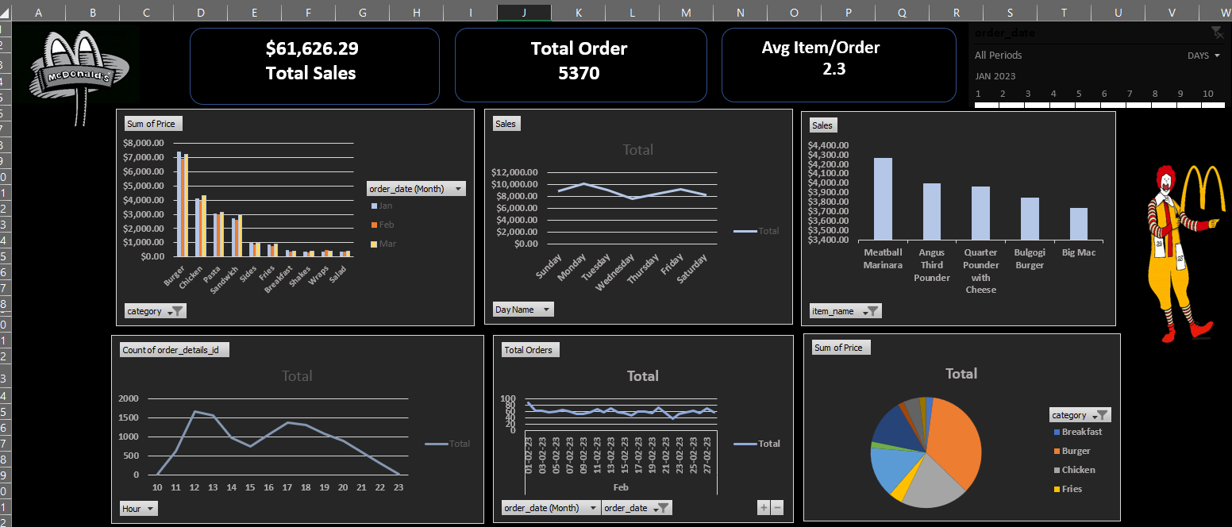

Key Findings:
- Meatball Marinara contributed the highest revenue, while Side Salad recorded the most orders but lower average value—indicating a strong opportunity for bundling.

- Sales peaked on Mondays and declined midweek, highlighting potential for targeted promotional campaigns.

- The busiest ordering periods were 12–2 p.m. and 5–7 p.m., supporting better staffing and marketing alignment during peak hours.

- Lower-performing items such as wraps and shakes could be improved through combo deals or limited-time offers.

- January outperformed February and March, suggesting the need for more effective seasonal and campaign-based planning.

Data Cleaning & Preparation

• Header Alignment:
Fix incorrect or missing column names, remove extra spaces, ensure headers match the data correctly.
• Data Type Adjustment:
Convert columns to correct types (e.g., text, number, date, decimal) to avoid calculation and analysis errors.
• Missing Values Handling:
Fill, replace, or remove null/blank values based on business logic.
• Duplicate Removal:
Identify and delete duplicate records to maintain accuracy.
• Data Integrity:
Ensure consistency, accuracy, and validity of data (e.g., correct IDs, valid ranges, proper relationships).

Data Transformation
• Merging Datasets:
Combine multiple data sources using common keys (e.g., Order ID, Product ID, Date) to create a unified dataset for analysis.
• Feature Engineering:
Create new meaningful variables such as total sales, average order value, profit margin, order frequency, and category flags to enhance insights.
• Time Segmentation:
Break data into time-based segments like hour, day, week, month, weekday vs weekend, and meal periods to analyze temporal patterns effective.

Data Modelling
Data Relationships: The “Menu-Items” and “order-Details” tables were modeled using the item ID as the common column, end data integrity across the datasets.

Data visualization and insights
The resulting dashboard provides a comprehensive view of McDonalds’s sales performance across various dimensions:
- Revenue Distribution
By Category: Chicken products are the top revenue generators, contributing
Significantly to overall sales.
By Time Period: Afternoon sales dominate, accounting for 48% of the total revenue, followed by evening and morning periods.

